This first part of this series is a focus on Docker and Terraform. I got this idea because I have been interested in learning Terraform as well as learning more about Docker. I knew that I would expand my homelab someday and I figured why not start doing that now to learn some new skills.
I used this repository from Tom Dean.
Before I hopped into using Docker and Terraform I wanted a better understanding of what infrastructure as code is. Which I found here.

What is IaC?
Infrastructure as Code (IaC) allows you to manage the infrastructure through the use of code instead of through the GUI. Management of the infrastructure can be; creating, provisioning, and destroying the infrastructure.
Some Benefits:
- Cost efficient: Keeps cost low by allowing you to destroy it
- Provisioning the same environment
- Reduce Risk

Installing Docker
The first thing that I did was installed Docker on Ubuntu. I followed the documentation from Install Docker Desktop due to the documentation saying that I could install Docker Desktop on Ubuntu.
They have instructions on installing a Gnome for non-Gnome environment but as I have already have Gnome I skipped this part.
Set up Docker’s package repository. Use Step 1 (code below)
# Add Docker's official GPG key:
sudo apt-get update
sudo apt-get install ca-certificates curl gnupg
sudo install -m 0755 -d /etc/apt/keyrings
curl -fsSL https://download.docker.com/linux/ubuntu/gpg | sudo gpg --dearmor -o /etc/apt/keyrings/docker.gpg
sudo chmod a+r /etc/apt/keyrings/docker.gpg
# Add the repository to Apt sources:
echo \
"deb [arch="$(dpkg --print-architecture)" signed-by=/etc/apt/keyrings/docker.gpg] https://download.docker.com/linux/ubuntu \
"$(. /etc/os-release && echo "$VERSION_CODENAME")" stable" | \
sudo tee /etc/apt/sources.list.d/docker.list > /dev/null
sudo apt-get update
Go to the link here, download the latest DEB package
Install the package with apt as follows:
sudo apt-get update
sudo apt-get install ./docker-desktop-<version>-<arch>.debhere
This is where I got the error: bash: version: No such file or directory. I looked through many different documentations to see what I could do. There was one person who said to put the version and arch in instead of having the code like it is. I did some more research and found the current version and arch. This did not work. I poured myself into research for a day but came up with nothing that worked. One of my connections messaged me about trying after sharing the error code with him:
sudo apt update
Sudo apt install docker.io docker-compose -y
This did not work either. While looking through documentation I ran across something for Installing Docker Engine on Ubuntu.
Uninstall all the conflicting packages:
for pkg in docker.io docker-doc docker-compose docker-compose-v2 podman-docker containerd runc; do sudo apt-get remove $pkg; done
Set up Docker’s apt repository:
# Add Docker's official GPG key:
sudo apt-get update
sudo apt-get install ca-certificates curl gnupg
sudo install -m 0755 -d /etc/apt/keyrings
curl -fsSL https://download.docker.com/linux/ubuntu/gpg | sudo gpg --dearmor -o /etc/apt/keyrings/docker.gpg
sudo chmod a+r /etc/apt/keyrings/docker.gpg
# Add the repository to Apt sources:
echo \
"deb [arch="$(dpkg --print-architecture)" signed-by=/etc/apt/keyrings/docker.gpg] https://download.docker.com/linux/ubuntu \
"$(. /etc/os-release && echo "$VERSION_CODENAME")" stable" | \
sudo tee /etc/apt/sources.list.d/docker.list > /dev/null
sudo apt-get update
Install the Docker packages. I used the latest but you can use a specific version if you have one in mind that you want to use.
sudo apt-get install docker-ce docker-ce-cli containerd.io docker-buildx-plugin docker-compose-plugin
Lastly test Docker using the “Hello World” image:
sudo docker run hello-world
This should output what the image below shows:
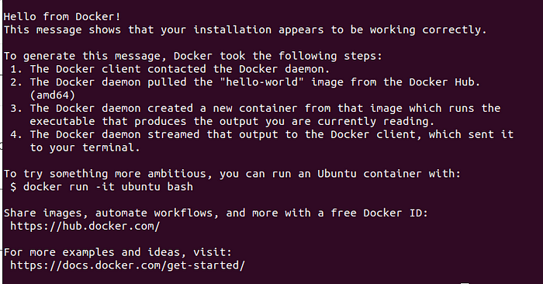
The last thing that I did was adding the user to the docker group. I tried:
$ sudo usermod -aG docker `$User`
You will have to log out and back in for this to work. If this worked for you than you can skip the next part and go onto installing Terraform.
This did not work for me as later on when I was doing the plan function for Terraform I got this error:
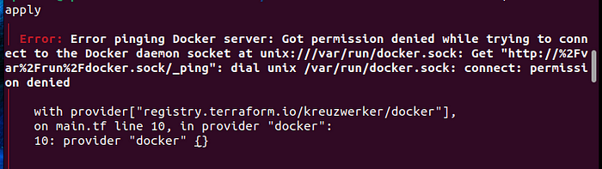
I found another document from Docker about Linux post-installation steps for Docker.
Create docker group:
sudo groupadd docker
Add user to docker group
sudo usermod -aG docker $USER
Log out and back in. The activate the changes to group
newgrp docker
Verify that you can run Docker again.
docker run hello-world
Then you should get this:

Install Terraform
The next step is to install Terraform. I did this through the Install Terraform documentation.
I made sure to click on Linux and the Ubuntu. You can click on whichever Linux distro you use.
Make sure that everything is up to date and that gnupp, properties-common, and curl packages are installed.
sudo apt-get update && sudo apt-get install -y gnupg software-properties-common
Install the HashiCorp GPG Key
wget -O- https://apt.releases.hashicorp.com/gpg | \
gpg --dearmor | \
sudo tee /usr/share/keyrings/hashicorp-archive-keyring.gpg
Verify the Key
gpg --no-default-keyring \
--keyring /usr/share/keyrings/hashicorp-archive-keyring.gpg \
--fingerprint
Add the official HashiCorp repo
echo "deb [signed-by=/usr/share/keyrings/hashicorp-archive-keyring.gpg] \
https://apt.releases.hashicorp.com $(lsb_release -cs) main" | \
sudo tee /etc/apt/sources.list.d/hashicorp.list
Update
sudo apt update
Then install Terraform from the new repo
sudo apt-get install terraform

Create Infrastructure as Code
Next up is creating a configuration file that provision a nginx container on Docker.
You will have to create a working directory for Terraform. You will need to create a directory called terraform-test then you change the working directory to that directory.
$ mkdir terraform-test
$ cd terraform-test
Next create a file with the Terrafrom code. The touch command creates the main.tf file into the terraform-test directory
$ touch main.tf
Next part is to input the code into the main.tf file. The cat command inputs text into the file.
$ cat > main.tf
Then type:
terraform {
required_providers {
docker = {
source = "kreuzwerker/docker"
}
}
}
provider "docker" {
host = "unix:///var/run/docker.sock"
}
resource "docker_container" "nginx" {
image = docker_image.nginx.name
name = "nginx_container"
ports {
internal = 80
external = 80
}
}
resource "docker_image" "nginx" {
name = "nginx:latest"
}
Then hit Ctrl+C to end writing in the file.
The next step is to deploy what you have written.

Deploy
Before deploying the infrastructure as code you need to initialize Terraform.
$ terraform init
This should out put something like:
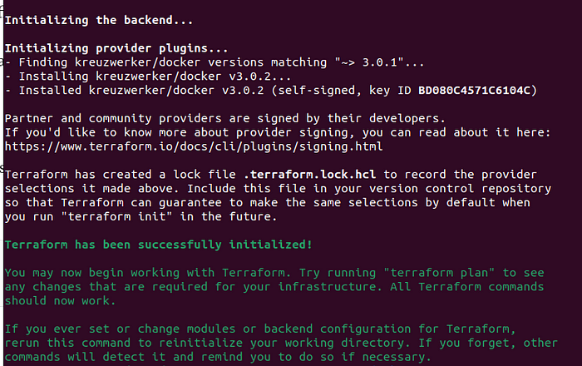
Validate your Terrafrom Configuration and see what you’re building.
$ terraform plan
Keep doing the plan command until you get no errors.
Now it’s time to provision your resource.
$ terraform apply
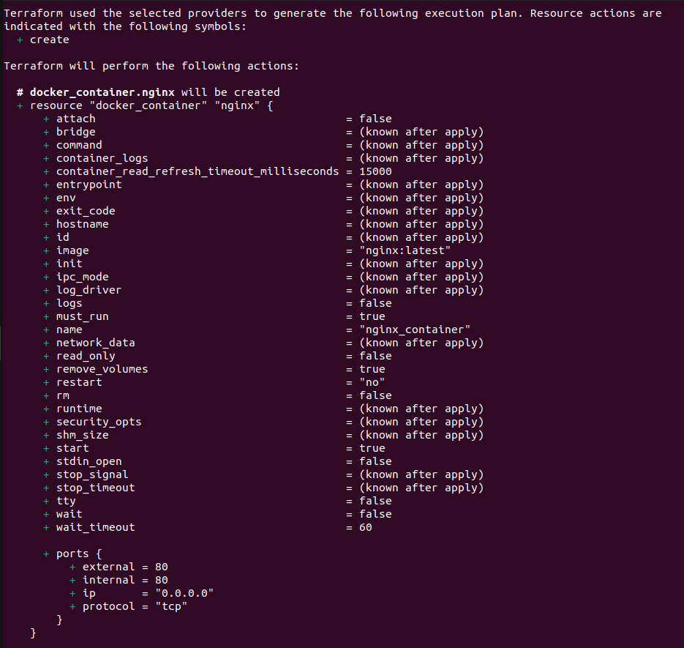
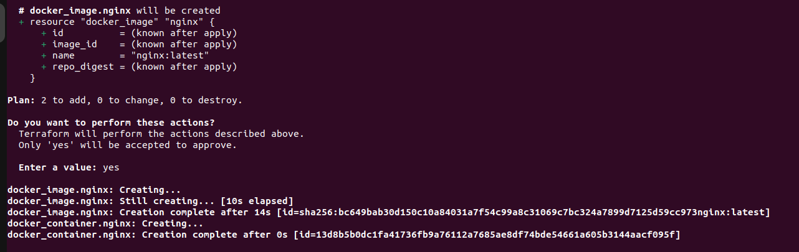
Make sure that you type in “yes”. This is one step that I did not do at first and I thought I messed things up but after looking through the repo again and doing it over a few times I realized the human error I made.
You can check if these results through looking in your browser at localhost:80 or you can run:
$ docker ps -a
or:
$ curl http://localhost:80
I did not do the last two options but went through the localhost option and saw that it worked.

Destroy Infrastructure as Code
Tearing down the infrastructure is easier than deploying it.
$ terraform destroy
Make sure that you type “yes”. The result should look like this:
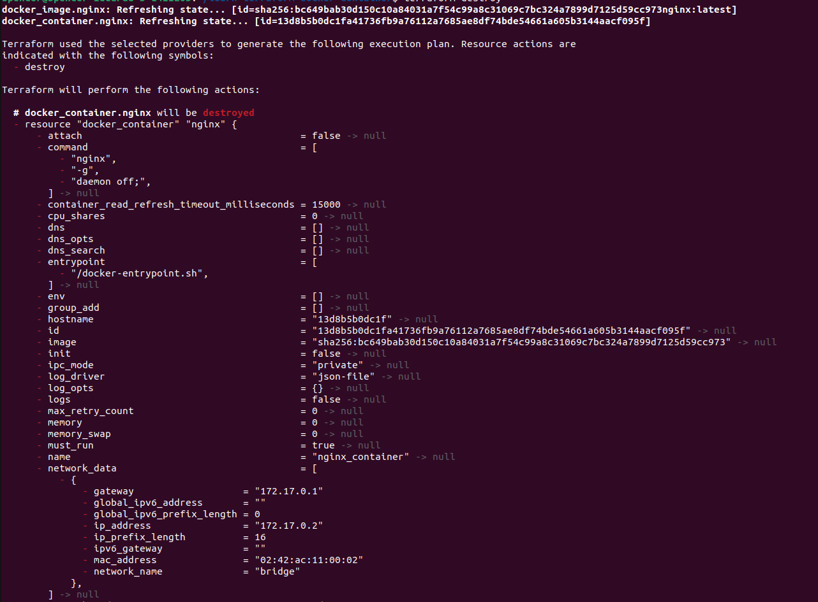
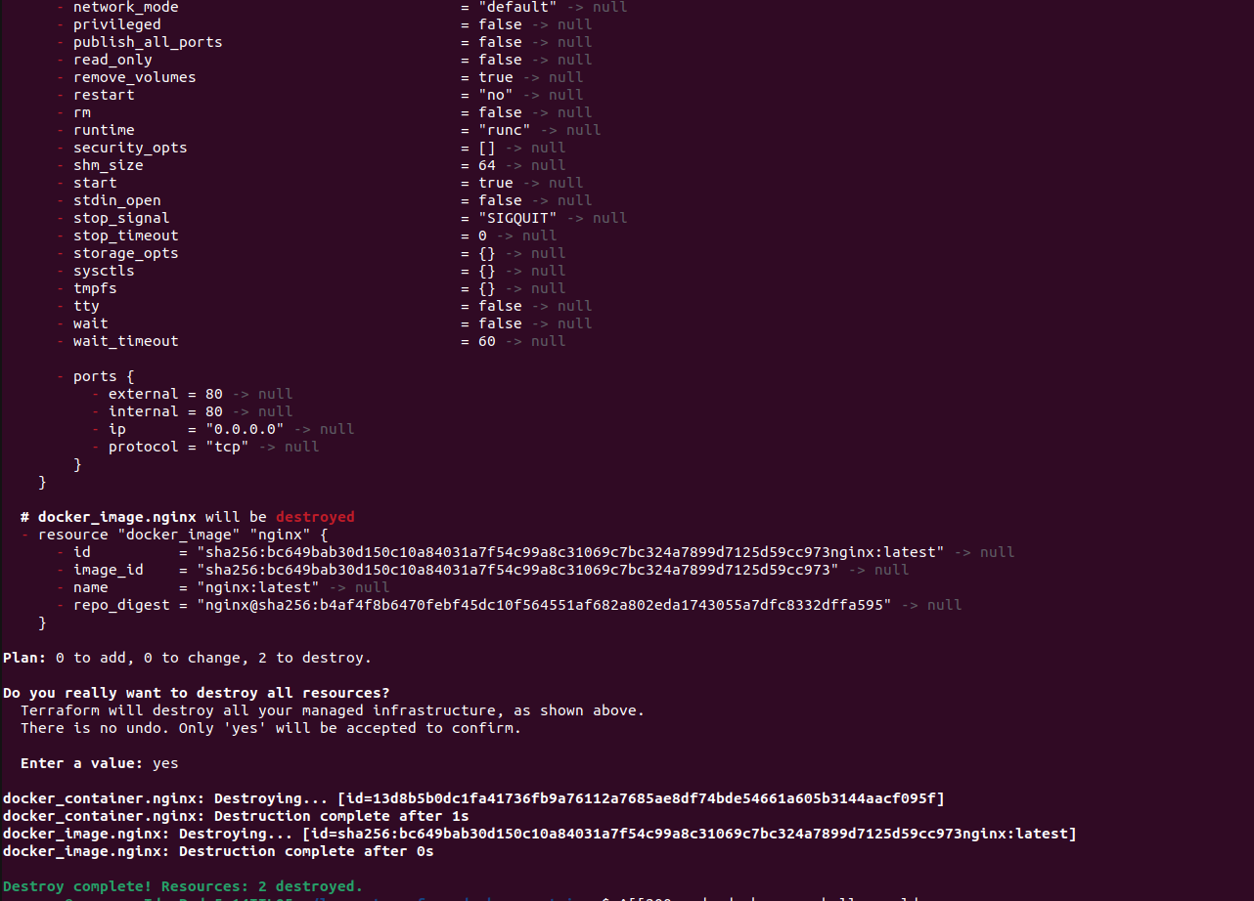
You can use three options when verifying that it was destroyed:
First option:
$ curl http://localhost:80
Second option:
$ docker ps -a
Last option is using the Docker image and making sure that it is removed:
$ docker images

Conclusion:
I had a lot of fun working with Terraform and Docker on Ubuntu. Building the Docker infrastructure and making it work. My next phase of this will be combining Terraform and KVM. Hope you can join me on my journey in learning new tools and expanding my homelab.

Resources:
Dean, Tom. “Hands-On-With-Terraform-On-Linux/ at Main · Southsidedean/Hands-On-With-Terraform-On-Linux.” GitHub, github.com/southsidedean/hands-on-with-terraform-on-linux?search=1#hands-on-with-terraform-on-linux.
“Install Docker Desktop on Ubuntu.” Docker Documentation, 20 Oct. 2023, docs.docker.com/desktop/install/ubuntu/.
“Install Docker Engine on Ubuntu.” Docker Documentation, 20 Oct. 2023, docs.docker.com/engine/install/ubuntu/#install-using-the-repository.
“Install Terraform | Terraform | HashiCorp Developer.” Install Terraform | Terraform | HashiCorp Developer, developer.hashicorp.com/terraform/tutorials/aws-get-started/install-cli.
“Post-Installation Steps for Linux.” Docker Documentation, 10 May 2022, docs.docker.com/engine/install/linux-postinstall/#manage-docker-as-a-non-root-user.
“What Is Infrastructure as Code with Terraform? | Terraform | HashiCorp Developer.” What Is Infrastructure as Code with Terraform? | Terraform | HashiCorp Developer, developer.hashicorp.com/terraform/tutorials/docker-get-started/infrastructure-as-code.

